This system requires some special libraries and linkers which aren't easily accessible in Dev C++ or CodeBlocks. To encounter that, we have used Visual Studio and downloaded the C++ package.

The user can either download Visual Studio and the aforementioned package to compile the system or they could run the already compiled executables. It is possible that the user’s computer might not be able to run the .exes files due to missing libraries or lacking the C++ run time ability. In that scenario, the best option would be to download Visual Studio.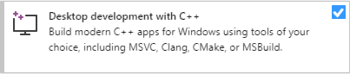

**Local:**

You can run both exe’s/programs on the same computer by simply typing the localhost address 127.0.0.1 when prompted by the client.

Note: You can’t run two projects at once in Visual Studio, so you’ll have to use an exe after compiling. (compile the server side code, and run the exe produced. Then open the client in VS and run it)

**Different PC’s**

The only difference here is that you need the IP of the server, which is no longer localhost. To find this IP, on the computer which the server is running, go to the command prompt and type ipconfig. This will show you a list of details including the IP(ipv4). Type this IP into the client side to connect.

However the requirement is that both must be connected to the same local wifi.